SWA Functional Documentation

1) TRF (Test Requistion Form)

- Create TRF Form (Form can be classified in 3 category – Soil (SQ) , Water (WQ) , Air (AQ))

TRF Form has following common fields For all category listed below:

- Name Of Customer
- Sample Id Number
- Address , Telephone / Fax No. & Email ID
- Sample Identification If Any
- Sample Collection Date and Time
- Sample Submission Date and Time
- Quantity of sample
- Sample Collect By (Have Selection – Customer or Lab Personnel)
- Mode Of Sampling (Have Selection – NA or Grab or Composite)
- Environmental Condition during sampling
- Sample Preservation as per Standard (Tick any one - Yes , No , Not Applicable)

AT the last of TRF has button Want Regulatory Limit? -> Dialogue Box open

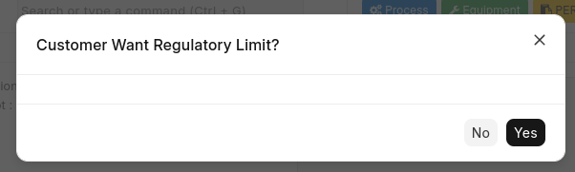

Figure - 1.1

When Click to Yes In TRF Category Wise all table has regulatory limit fields this can be fetch from the table and set.
if No then by default “-” is set.

Sample ID Number Wise Field Listed below:

Description : TRF Form Create , Dialogue Box open tick any one then According to checkbox value Sample Id Number Generate

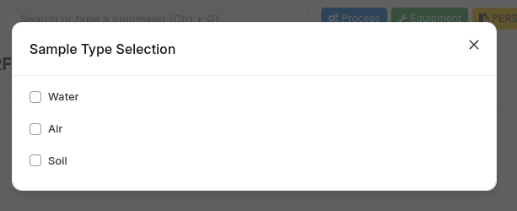

Figure – 1.2

For Example , Above Given Picture lets Undenstang How Sample Id Generate

If Select Water then The Id Will be (WQ/01/25) ( WQ for Water , 01 is number which is increamental , 25 is current year)

If Select Soil then The Id Will be (SQ/01/25) ( SQ for Soil , 01 is number which is increamental , 25 is current year)

If Select Air then The Id Will be (AQ/01/25) ( AQ for Air , 01 is number which is increamental , 25 is current year)

-> Sample Id Wise Fields Display in TRF Form All the Sample Type Category Has Different Tables And Parameter category wise.

1) Water Quality Parameters

Physio Chemical Parameters
List Of parameter :

Organic Nitrogen
Total Phosphorus
Ortho Phosphate
Fluoride
Silica
SAR
Potassium
Sodium
Magnesium
Magnesium Hardness
Calcium
Calcium Hardness
Total Hardness
Sulphide
Sulphate
Carbon Dioxide
Alkalinity
Acidity
Chloride
Residual Chlorine
Total Nitrogen
Nitrite
Nitrate
Ammonical Nitrogen
TKN
BOD
Dissolved Oxygen (DO)
COD
SVI
VSS
TSS
TDS
Temperature
Odour
Total Solids
Turbidity
Colour
Settleable Solids
Conductivity
pH

Microbiological Parameters
List Of parameter :

E.coli Coliforms
Total Coliforms
Fecal coliforms
Fecal Streptococci
total plate count

Organics – Genral/Trace Parameter
List Of parameter :

Poly Aromatic Hydrocarbon
OPP Pesticide - Parathion
Tannin & Lignin
Poly Chlorinated Hydrocarbons each
OPP Pesticide - Chloropyriphos
OPP Pesticise - Methyl Parathion
OPP Pesticide - Malathion
OCP Pesticide - Endosulfan
OCP Pesticide - Aldrin
OCP Pesticide - DDT
OCP Pesticide - BHC
Oil & Grease
Phenol

Heavy Metals Parameter
List Of Parameter:

Total Iron
Ferrous Iron (Fe +2)
Hexavalent Chromium
Arsenic
Barium
Boron
Cadium
Manganese
Mercury
Nickel
Iron
Lead
Lithium
Copper
Selenium
Total Chromium
Vanadium
Zinc

Toxicological Parameters
List Of Parameter:

Bioassay Using Fish

2) Soil Parameters

Physical Parameters - Soil/Sediments & Solid Wastes
List Of Parameters:

Moisture (Water Content)
Total Soluble solids
Electrical Conductivity
pH

Chemical Parameters - Soil/Sediments & Solid Wastes
List Of Parameters:

Organic Phosphorus Unignited
Organic Phosphorus Ignited
Cation Exchange Capacity
Sodium Adsorption Ratio in Water Extract
Exchangeable Potassium
Soluble Potassium
Extractable Potassium
Nitrite
Nitrite and Nitrate Nitrogen
Ammonical Nitrogen
Nitrate
Total Nitrogen In. No3
Total Nitrogen Ex. No3
Organic Phosphorus
Total Phosphorus
Available Phosphorus
Soluble Sulphate
Boron
Organic Matter
Organic Carbon
Chloride
Exchangeable Magnesium
Exchangeable Calcium
Soluble Magnesium
Soluble Calcium
Soluble Calcium + Magnesium
Extractable Magnesium
Extractable Calcium
Extractable Calcium + Magnesium
Calcium Carbonate

Heavy Metals &Alkaline/Earth Metals
List Of Parameters:

Exchangeable Sodium
Soluble Sodium
Extractable Sodium

Heavy Metals - Soil/Sediments & Solid Wastes
List Of Parameters:

Lead
Zinc
Vanadium
Total Chromium
Selenium
Nickel
Mercury
Manganese
Lithium
Iron
Copper
Cadmium
Barium
Arsenic

Other Parameters
List Of Parameters:

Calorific Value

3) Air Quality Parameters:

Desctiption : Air Parameter classified in 2 category
- Stack Air Quality
- Air Ambient Quality

Stack Air Parameters
List Of Parameters:

Carbon Dioxide(CO2)
Carbon Monoxide (CO)
Oxygen (O2)
Ammonia (NH3)
Oxides of Nitrogen (NOx)
Sulfur Dioxide (SO2)
Particulate Matter (PM)
Flow Rate

Air Ambient Parameters
List of Parameters:

Temperature
Barometric Pressure
Hydrogen Sulphide
TSPM
Xylene
TVOC
Total Aromatic Compounds
Toluene
Wind Speed
Wind Direction
Solar Radiation
Rainfall
Humidity
Benzene
Illumination
Noise
Ammonia
Nitrogen Dioxide
Sulfur Dioxide
Particulate Matter PM 10
Particulate Matter PM 2.5

Given Above All Category Wise Parameter Display on selection base in TRF From.

According Sample Type Selection from Diologue box , We can see category wise table in TRF have listed parameters in the Row.

*******TRF Process Flow for Conditional Form Creation*******
[For Water and Soil Category Sample Type]
The Sample Collect By field will have the following options : 1. Customer 2. Lab Personnel

Sample Collect By - Customer
- Water Category: No form will be created when Customer is selected.
- Soil Category: No form will be created when Customer is selected.

Sample Collect By - Lab Personnel
- Water Category: If Lab Personnel is selected, an Onsite Sampling WQ form will be created automatically with the sample ID number.
- Soil Category: If Lab Personnel is selected, an Onsite Sampling SQ form will be created automatically with the sample ID number after the TRF is saved.

[For Air Category Sample Type]
When the user fills out the TRF form and selects Air as the Sample Type, the following logic will be applied:
- Show Tables:
  - If Air is selected as the Sample Type, display the two tables:
    - Air Ambient Quality Table with its parameters.
    - Stack Air Quality Table with its parameters.
- Allow Parameter Selection:
  - The user can select parameters only from one table at a time.
    - If the user selects a parameter from the Air Ambient table, they cannot select parameters from the Stack Air table, and vice versa.
  - If Air Ambient parameters are selected:
    - Only parameters from the Air Ambient table will be available for selection.
    - A corresponding Air Ambient Quality Form will be generated upon saving the TRF.
  - If Stack Air parameters are selected:
    - Only parameters from the Stack Air table will be available for selection.
    - A corresponding Stack Air Quality Form will be generated upon saving the TRF.
3. Condition for Noise parameter when select From air ambient table
- If the Noise parameter is selected from the Air Ambient table, a Noise Monitoring Form will be generated instead of the Worksheet.
- The Worksheet will not be generated for this specific parameter when Noise is selected.
- Noise Monitoring Form Display in Sidebar menu
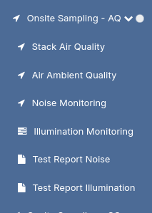

Figure 1.3
- In the Noise Monitoring Form “Generate Test Report”
After selecting the desired parameters in the TRF form, once saved, the system automatically generates the appropriate conditional base form.

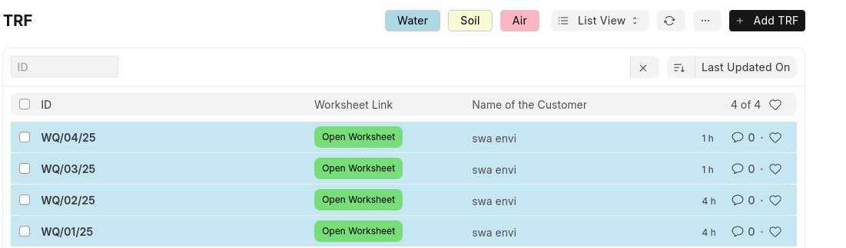
- In above Image is shown list of TRF where in Worksheet Link has button named “Open Worksheet” when click to this button coresponding worksheet is open here .

- Also there 3 button there Water , Soil and Air when click to Water only Water sample is display (like id start with WQ)

- When click to Soil , only soil sample is display (like id start with SQ)

- When Click to Air , only Air sample is display (like id start with AQ)

- if do not want any filter then click to close icon all the Sample Id data is display.

2) Sample Inward Register

- After save TRF Form , Sample Inward Register Form is automatic created.
- Fields in Sample Inward Register auomatic set from the TRF Forms
- Fields in Sample Inward Register
Company Name , Sample Collection Date , Sample Receipt Date , Sample Receiver Signature , Sample Id Number ,
Report Number , Remarks Or Special Instruction by customer or sampler

- In above Report Number is only Set when test report created.

- Sample Inward Register is one kind of register also we can Export all the data in Excel and CSV format For this Apply below steps:

Step:1 Select all the Record

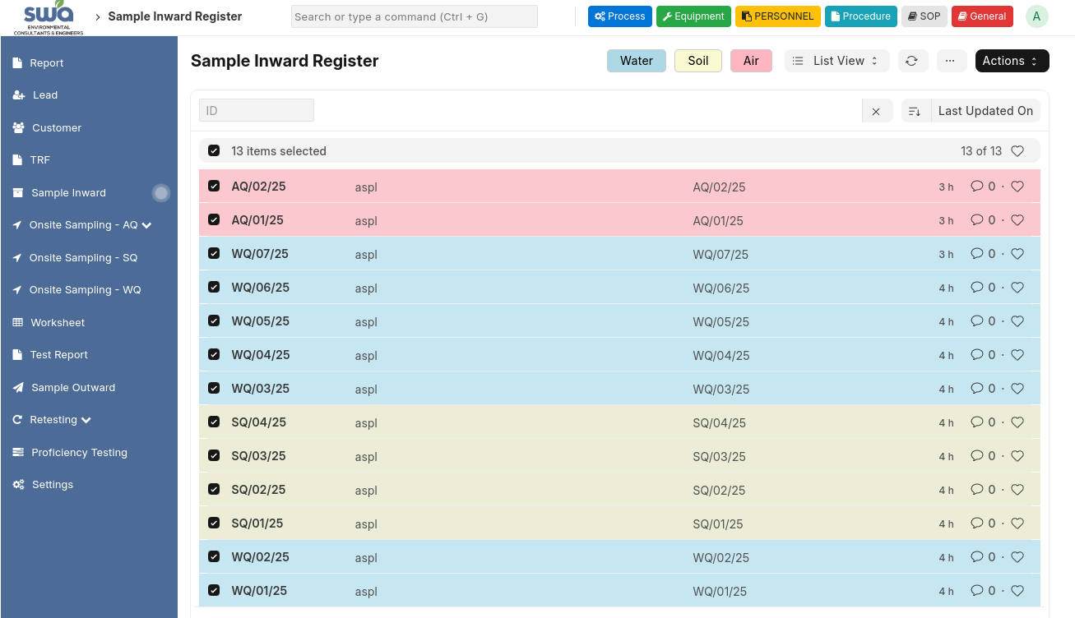

Steps

Figure – 1.4
Step:2 Click to Action Button -> Click Export
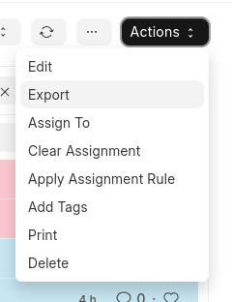

Figure – 1.5
Step:3 Popup box is open where you can select in which format you want to export this data select this also you can select feild according to our requirenment after click to Export Records File Will be downloaded into your system at Download Folder
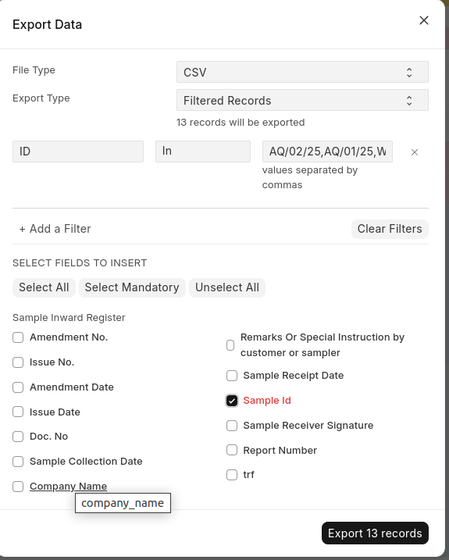

Figure – 1.6

- List of Sample Inward Register has also 3 button Water , Soil and Air same like TRF Work here.

2) Worksheet
Worksheet Common Fields:
Analysis start date
Analysis Completition Date
Sample Allocated to
Date Of receipt
Sample Id Number
Sample Type (category wise different values in selection)
Water (WQ):
(Wastewater , Drinking water , Ground water , surface water)
Soil (SQ) :
(Soil , Sediment , Solid Waste , Sludge , Slurry , Semi-Solid , Liquid)
Air (AQ) :
(Flue Gas emission , Process , vent emission)

Note:
When Select Illumination Parameter From the TRF above Fields will not display have another fields listed below:

- Fields Display in Worksheet for Illumination Parameter
Name Of Customer
Address Of Site
Date Of Sampling
Illumintion Onsite Datasheet No
Data Recorded by
Protocol Used For Monitoring
Location of sampling
Instrument Id Number
Average Illumination Level(LUX)
Area Categorization (Selection – Industrial , Workplace , Commercial)

Description:
- After the TRF form is saved, the Worksheet is automatically created with all the parameters selected in the TRF.
- All parameters are displayed in specific tables, each corresponding to their unique formula.
- In the Worksheet, parameters with the same formula are grouped together in the same table, while parameters with different formulas are placed in separate tables.

Condition in Worksheet:
- The Worksheet will only be accessible once the corresponding form (such as Onsite Sampling WQ for Water or Onsite Sampling SQ for Soil) is generated after saving the TRF form.
Formula Calculation For Parameter in Worksheet :
- Each Parameter is classified in worksheet and has different formula
- When the table are display in Worksheet the parameter select in TRF that particular parameter table will be display in Worksheet with have all Formula Fields need for each and every parameter
- all the parameter has different calculation so for this create different table by using parameter name with its formula fields.
- In below image see the parameter with its table
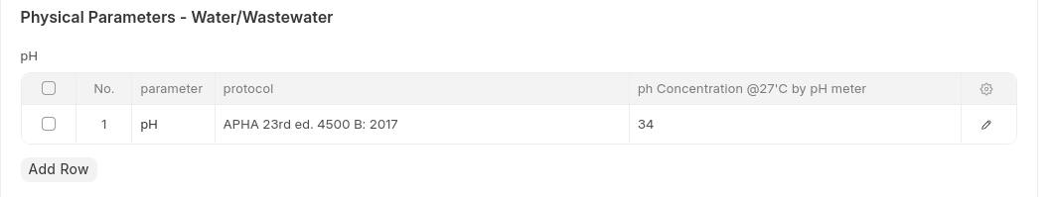
Figure – 1.7
- when click on the row you will be able to display popup box for particular parameter
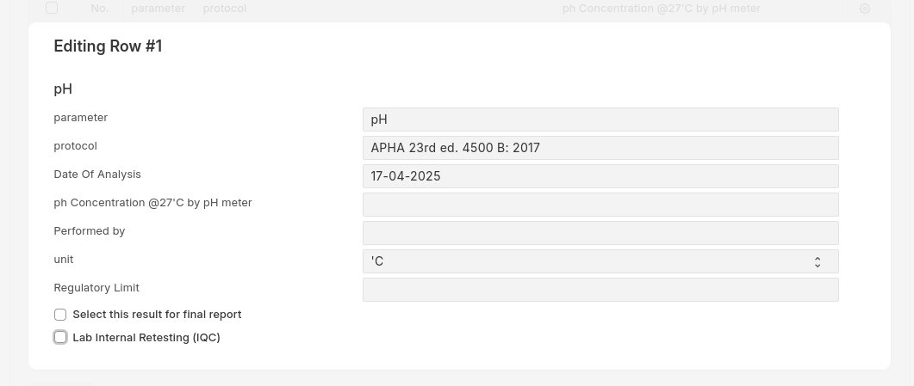

Figure – 1.8
- In Figure 1.4 will se 2 checkbox have lable
Select This report for final Report and Lab Internal Retesting (IQC)
- Above 2 field are present in all the parameter table will decribe later what about Lab Internal Retesting.
- Let’s Understand how Select this report for final Report work?
- All the parameter table has this name check box . When there is multiple test done for parameter among one want to display in test report just click to this check then only this check box parameter row result are display in final test report.
- When Multiple testing happen then test report name can be set with Sample Id Number after – R1 , R2 ,....(incremental)
- In parameter table Formula result automatic calculate according to value and that is read only we can not change it.
- After all parameter calculate In Worksheert form Top of “Generate Test Report” button is display.
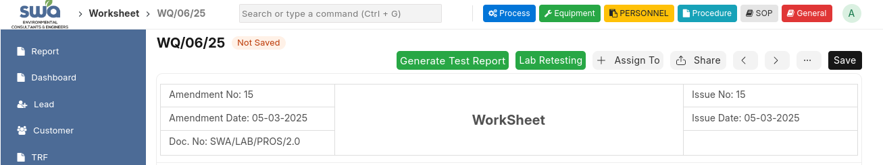

Figure – 1.9

- After save Worksheet click to Generate Test Report Button it Will Automatically generate the Test Report Form

- All the Parameter tables , (name , unit , Final Result , Method , Regulatory Limit will be display on Test Report.

- Final Result fetch according to unit selection in each parameter table.

Illumination Parameter

For Illumination Parameter Workhseet Will not display “Generate Test Report” Button it display “Generate Illumination Report”

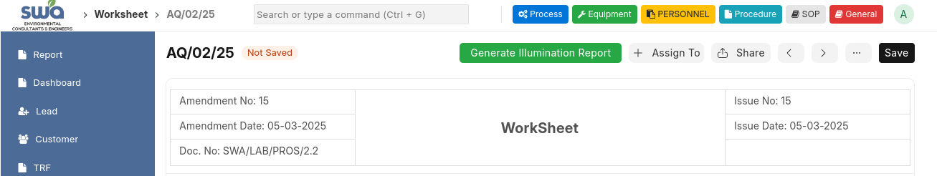
Figure – 1.6

Figure – 2.0

Figure – 2.0

After generate Report For the Illuniation Parameter Report Generate in Test Report Illumination Form. Test Report Illumination form also display in sidebar refer Figure – When Click to this menu able to Show all the List

- Parameter Selection:
  - When the Illumination parameter is selected in the Worksheet parameter table, additional functionality is enabled.
- File Attachment:
  - A File Attach button will be displayed in Illumination parameter table.
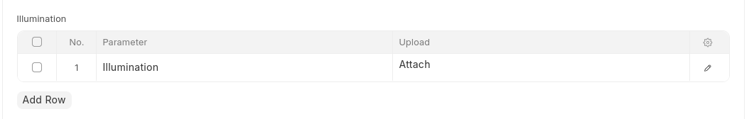
Figure – 2.1
  - Users can select an upload a file from their system.
  - The uploaded file is saved into the software.
- Access Uploaded Files:
  - In the sidebar, under the Onsite Sampling – AQ dropdown menu, there is an option named Illumination Monitoring all the file save here.

Figure – 2.2

- In Worksheet Listview , same like TRF has three button Water , Air , Soil

- When click to Water , only Water Sample ID display (like Sample Id start with WQ)

- When click to Soil , only Soil Sample ID display (like Sample Id start with SQ)

- When click to Air , only Air Sample ID display (like Sample Id start with AQ)

- Have also “Import Excel” button in worksheet listview , when click to this we can import bulk data into worksheet parameter table has field.

- For import data there is specific structure follow for this.

5) Test Report

- Once Test Report Generate from the Worksheet all The Report are display in Test Report Form.

- Test Report Fields are:

Company Name
Comoany Contact No.
Analysis Start Date
Report URL Number
Condition Of Sample
Sample Drawn By
Quantity Of Sample
Date Of Sample Received
Analysis Completition Date
Temperature / Humidity During Testing
Report Date
Report Code
Table ( For Display Final Result of parameter have – parameter name , unit , final result , method , regulatory limit)

- In the above all Fields are fetch Automatically From the Worksheet And TRF

- In Report URL Number – this url is automatic generate when test report create And genarte also series wise.

For Example : TC4142250000000001F

- In Report Code – this Code also generate automatic while test report create

For Example : SWA/LAB/21/04/2025/WQ/01/25
In above code : SWA/LAB is the static.
21/04/2025 is the current date
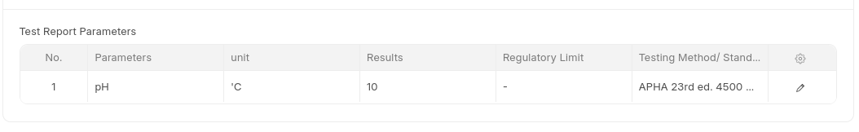
WQ/01/25 – is the sample id number of test report

Figure – 2.3
- in the above figure when test report generate from Worksheet all the Parameter and its method , final result and regulatory limit automatic fetch and show in test report like above figure.
- When test Report is create first it is in Draft status , in the test report list view we can see the Test Report status.
- Now in Test Report when the form save like below figure will change the buttom from save to submit in test report form.
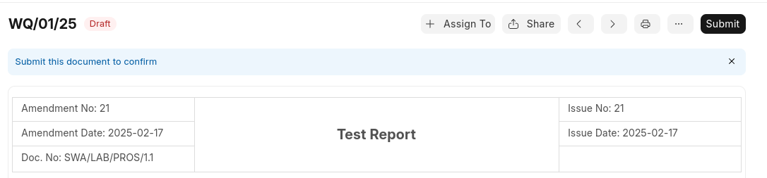
Figure – 2.4
- Once Click to Submit button Dialogue Box Open.
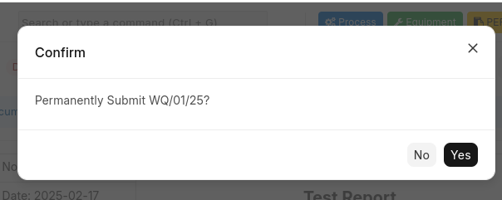

Figure – 2.5
- When Click to Yes The Form status is now converted to Submitted.

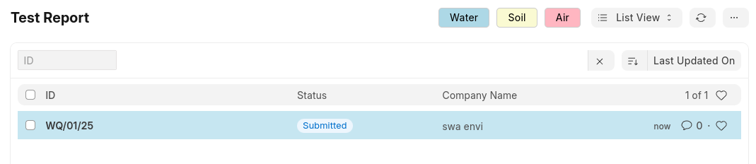
Figure – 2.6
- Print Option:

- Test Report Form Also has customize Print Format

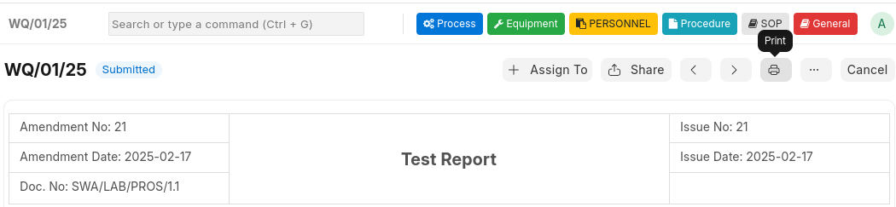
Figure – 2.7
- Form has Print Icon button when click to this

- For Print Customization , create the format for print in Test Report according to our requirement.

- When Format Create for Test Report set this print format in Test Report.

- Below Figure Shows the Print Format For Test Report.

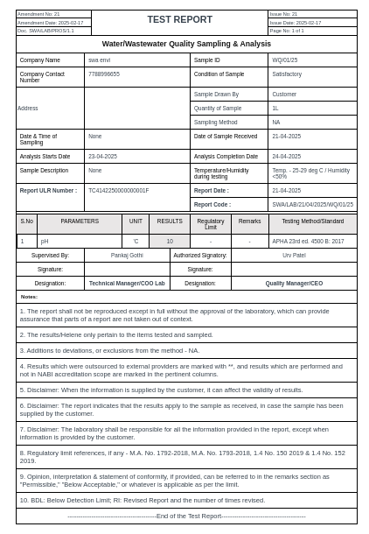

Figure – 2.8

- List of Test Report has also 3 button Water , Soil and Air same like TRF Work here.

6) Sample Outward Register

- Once Test Report Generate , after 15 days Automatically Sample Outward Register Form is create for that particulat Test Report.

- Sample Outward Register Feilds are:

Date
Company Name
Purpose ( Sub-Contracting / Retesting / Disposal)
Quantity
Outward Number
Signature For Authorization

- Date , Company Name , Quantity , Outward Number values are automatic set When Record is created.

- If want to Download Register same like Sample Inward Register follow the steps.

- List of Sample Outward Register has also 3 button Water , Soil and Air same like TRF Work here.

7) Retesting

- Retesting Parameter is Tested By lab After 1 month , this parameter is select from the worksheet , retesting worksheet Form is create is the same as Worksheet all feild are also same.

- How the Parameter is select for Retesting Worksheet??

- Explaination ::

- Worksheet Form discussed above , in the Worksheet Form has Individual Parameter table all the table has one check box with label “Lab Internal Retesting (IQC)” , For Example:
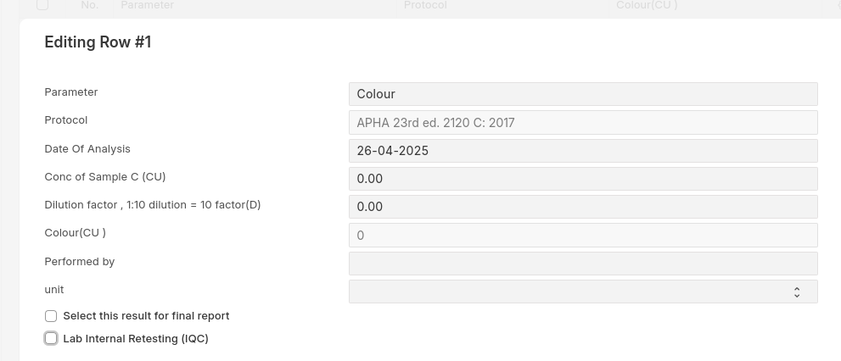

Figure – 2.9
- When check on this checkbox , according to requirement , save the worksheet.

- In Worksheet Lab Retesting Button is Shown.

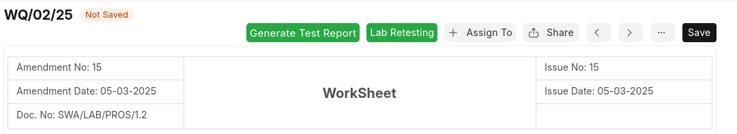

Figure – 3.0

- Once check Parameter For Lab Internal Retesting save the Worksheet and click to this button Lab Retesting from the worksheet.

- All the parameter select for lab internal retesting are fetch in Retesting Sample Form with the same sample id number from worksheet.

- Retesting Sample Form is for calculate parameter with formula is same as Worksheet. In retesting Sample Calculate formula result same as do in workshhet. After done , save the Form.

- Also the condition apply here is that all the parameter date of analysis date must equal or after the analysis start date if not then it will not allow to set the date. And in anlaysis completion is the latest date from all the parameter table’s date of analysis date.

- Once retesting sample is save inside Save button “Generating Retesting Report” button is shown click to this. When click Retesting Report create same like Test Report all fields are automatic fetch and with all result.

- Retesting Report Form is display under Retesing label in sidebar menu

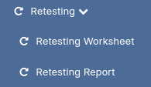

Figure – 3.1

- In Retesting Report same Sample id number record is created.
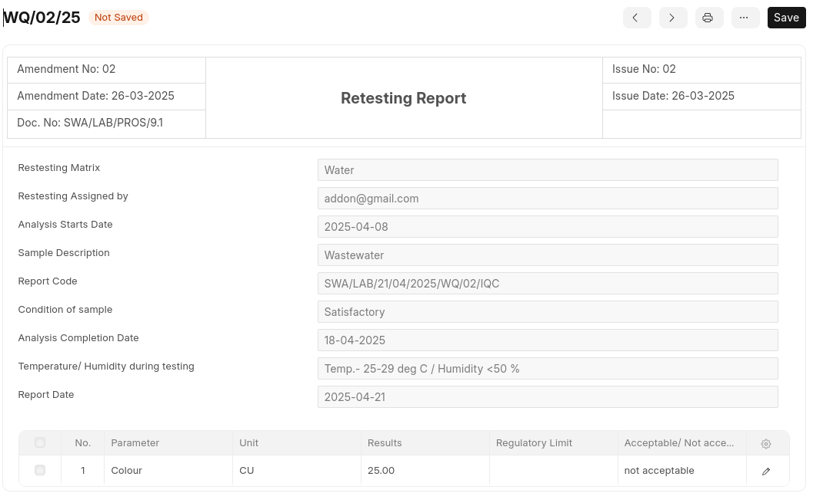

Figure – 3.2

- Above type Form is generate , All the result with parameter name and its method , unit , regulatory limit are list out in given form last table.

- For Acceptable / Not Acceptable result set automatic based on the current and previous result of the Parameter ( 20 %)

- Same Like Test Report , generate Retesting Report in Print Format . For This In Retesting Report has Print button when click to this The print Format report genate as follow.

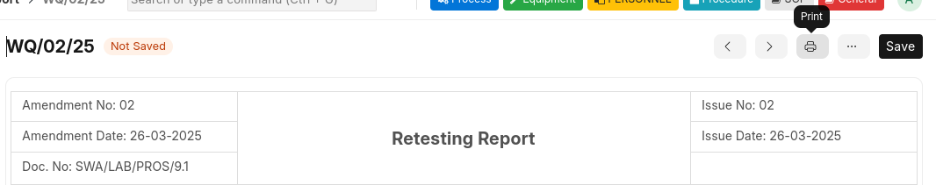
Figure – 3.3

- In Above Figure – Print Icon Display After click this Report in print format display like below.

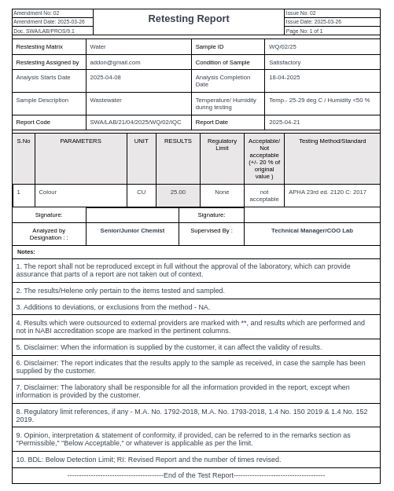

Figure – 3.4

8) Dashboard

- When click to SWA logo and also in home page , dashboard shown

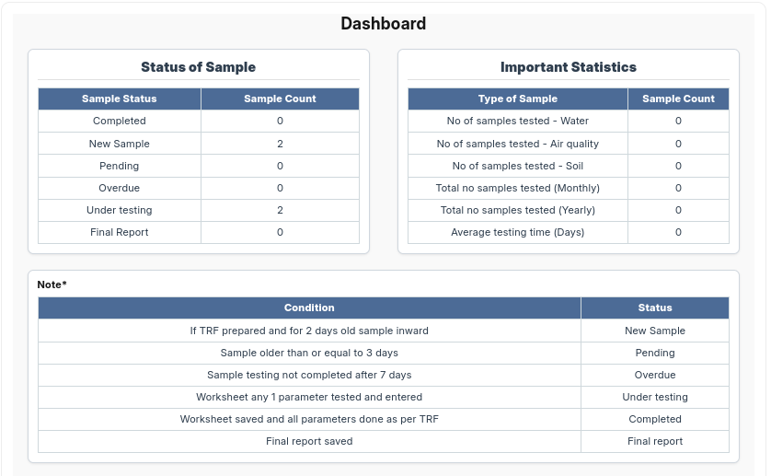
Figure – 3.5

9) Amendment Settings

- When Amendment number or issue number change In Sidebar setting Menu is display click to there

Figure – 3.6

- after click this below figure type open:
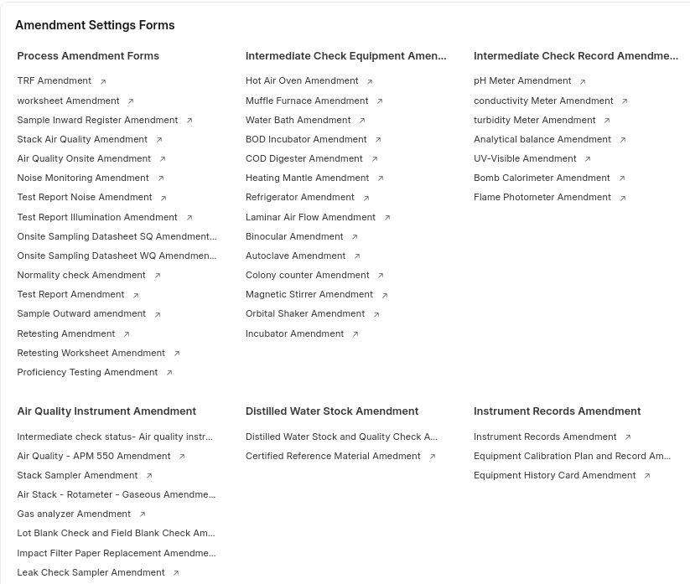

Figure – 3.7

- For all the forms has header Amendment no , date , issue no , date are fetch automatically from here.

- This is for partilcular form when click here , amendment no and issue no automatic increamental and date can be selected as want after save this data , in all form according to logic that last data fetch in header.

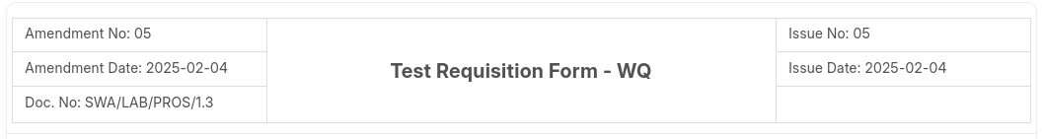
Figure – 3.8

- In above picture there is also one field doc no. It is automtatic create when form is created.

Equipment Part

- From the home page when click to equipment button will display all the forms comes under this category wise

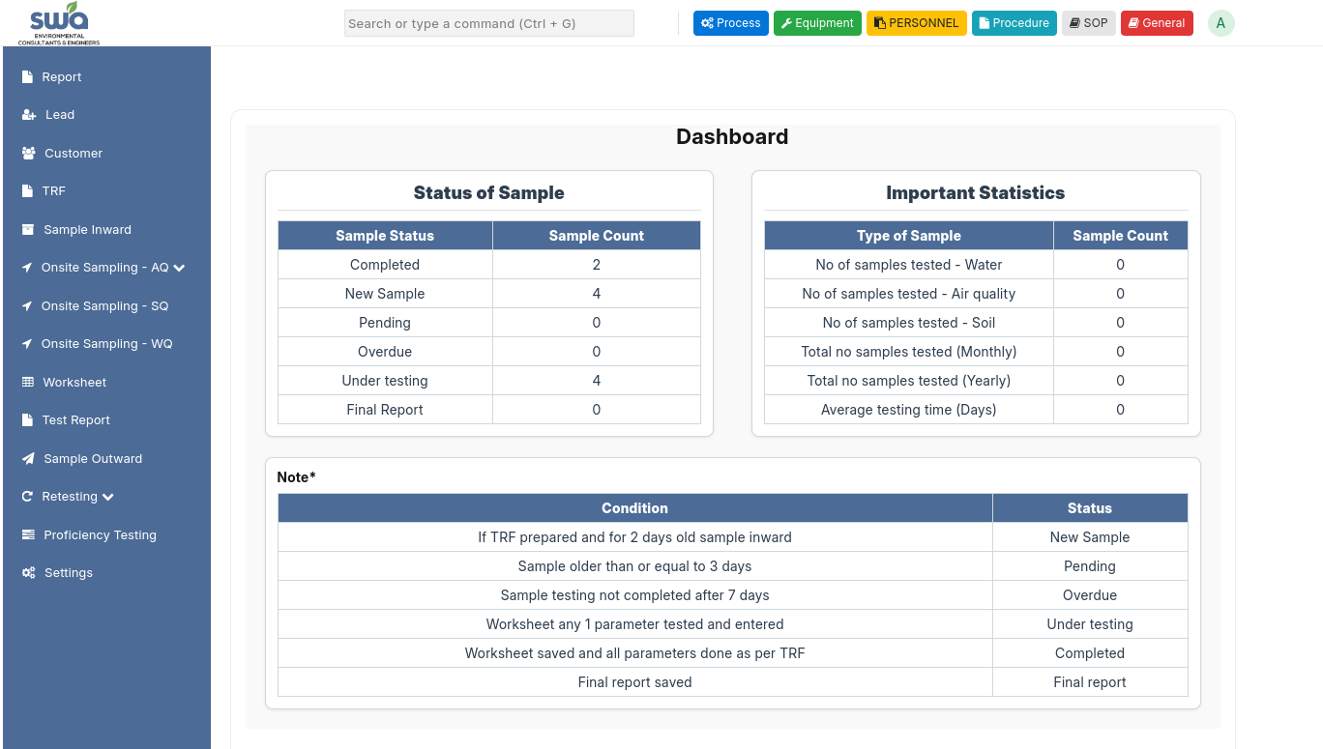
Figure – 3.9

Figure - 3.9
- After click below type is display
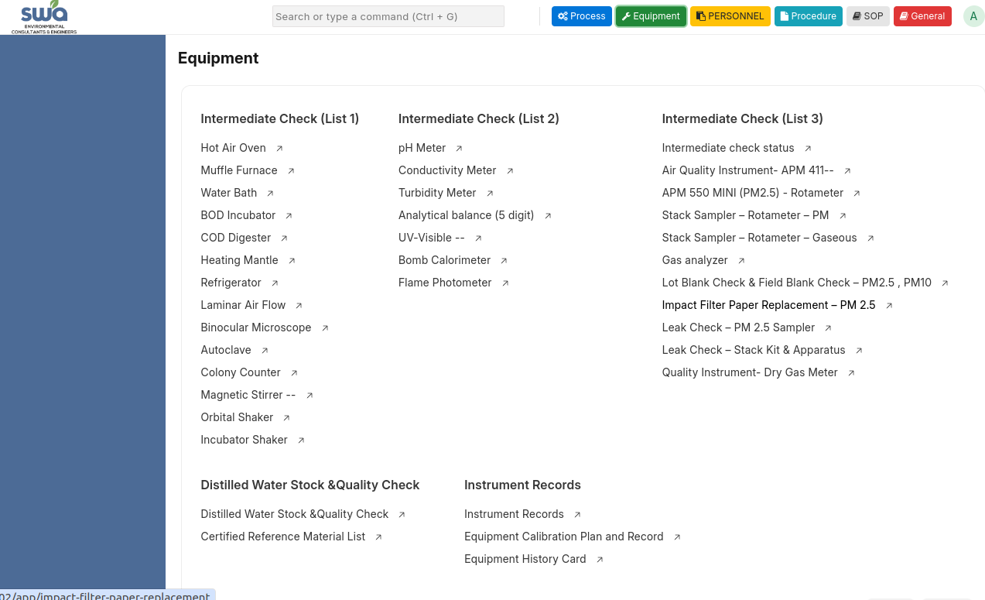

Figure - 4.0

- In above given figure 3 intermediate check list and also different from is display. When click to one tehere unique from is there for each one.

- Intermediate Checklist - 1 Structure and Form Rules
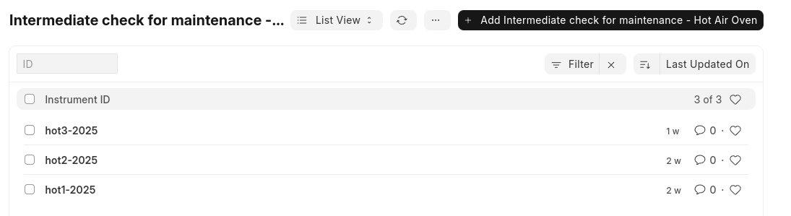
Figure – 4.1

- When click to any Form click to “Add Intermediate check for maintenance – Hot Air Oven” button -> form is open
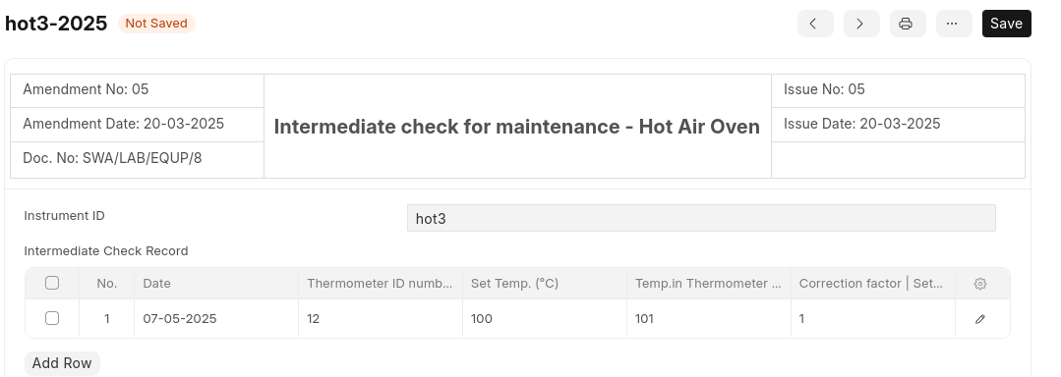
Figure – 4.2

1. Allow new rows only through the "Add Row" button
- Users can only add rows manually using the “Add Row” button.
- The form should only allow unique document name in the form Name Lable is present fill up that details upon save the document name is “name value - 2025” .
- Entry is mandatory for each month between the 1st and 5th date , by click to add row button.
- If the entry is not exist between 1 to 5th date in Equipment dashboard between 6 to 10 date Alert is generate.

Important Notes :
- The 1st and 2nd point of the intermediate checklist 1 must be applied to all forms.
- This type alert generate in Equipement Dashboard.
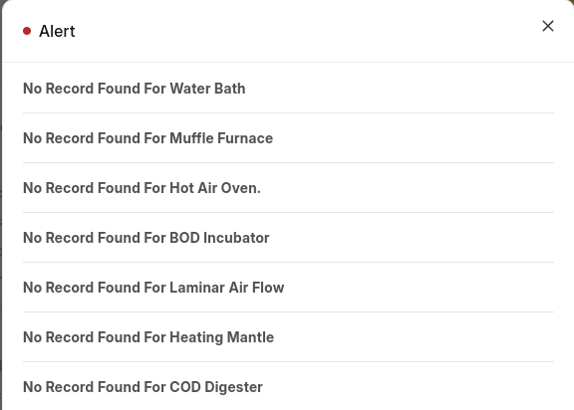

Figure – 4.3

Intermediate Checklist - 2 Structure and Form Rules
- Intermediate Checklist - 2 follows a similar structure to Checklist - 1, but some forms have a different entry style.

Forms that Follow the Same Structure:
These forms follow the same structure as Intermediate Checklist - 1:
- Intermediate Check Record – pH Meter
- Intermediate Check Record – Conductivity Meter
- Intermediate Check Record – Turbidity Meter
- Intermediate Check Record – Bomb Calorimeter

Forms with a Different Structure (Only Form Name Differs, Alert Logic is the Same):
- Intermediate Check Record – Analytical Balance (5-digit)
- Intermediate Check Record – UV-Visible Spectrophotometer
- Intermediate Check Record – Flame Photometer

Form Naming and Entry Rule
- When you click the "Add" button to create a new entry, fill in the form details as required.
- Name label is there , fill that value for example you fill the test1 then the Document name is test1 - MM/YYYY
- Upon saving, the form name should follow the format: test1 - MM/YYYY,
where:
  - MM = current month (e.g., 04 for April)
  - YYYY = current year (e.g., 2025)
So the name for April 2025 would be: test1 - 04/2025
- Here Per Year has 12 forms is created , per month one record must between 1 to 5 date if not create then alert generate.
- Intermediate Checklist – 3 Structure and Form Rules
- Intermediate Checklist - 3 follows a similar structure to Checklist - 1, but some forms have a different entry style.
- Forms that Follow the Same Structure:
1. Intermediate check for maintenance Air Quality Instrument- APM 411 (Gaseous Sampling – Air Ambient) - Rotameter
2. Intermediate check for maintenance Air Quality Instrument- APM 550 MINI (PM2.5) – Rotameter
3. Intermediate check for maintenance Air Quality Instrument- Stack Sampler – Rotameter – PM (Particulate Matter)
4. Intermediate check for maintenance Air Quality Instrument- Stack Sampler – Rotameter – Gaseous
5. Intermediate check for maintenance Air Quality Instrument- Gas analyzer
6. Lot Blank Check & Field Blank Check – PM2.5, PM10 Filters
7. Impact Filter Paper Replacement – PM 2.5 Sampler
8. Leak Check – PM 2.5 Sampler
9. Leak Check - Stack Kit and Apparatus
10. Quality Instrument- Dry Gas Meter
- Only One form in intermediate checklist – 3 has different way to do entry
Intermediate check for maintenance Air Quality Instrument - Intermediate check status
- In the above given form only entry per year allow , in the form there is month wise static record exist
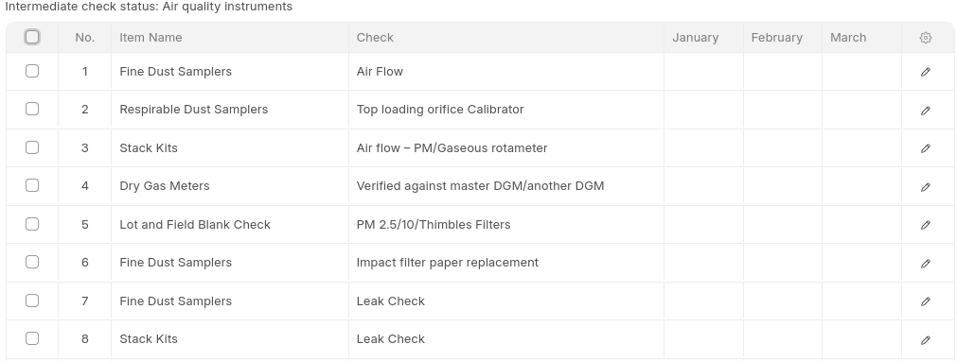
Figure – 4.4

- In above given above figure – 4.4 monthly record is already there when you click to row all month are display like below Figure – 4.5.
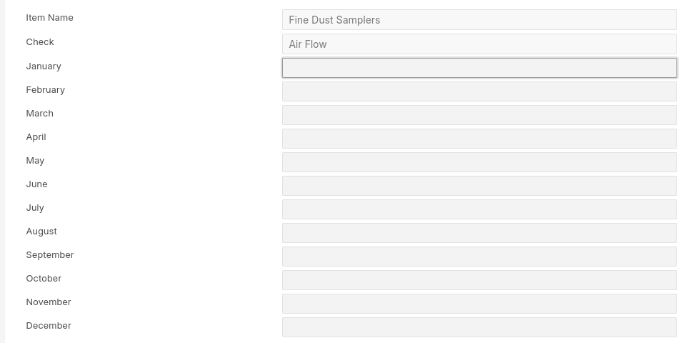
Figure – 4.5
- Now Let’s Understand How to do entry in form.
- Let’s Suppose current month is April , then in April month column all the row must be fill be with “yes” between 1 to 5 date, if not then same like other form alert generate between 6th to 10th date in equipment dashboard. (the value can be Yes , Y.. etc.)
Important Notes:
- Intermediate check list 1 , 2 and 3 Alert generate in every month’s 6 to 10 date between if no entry in 1 to 5 date.
- Distilled Water Stock and Quality Check – in this form also pe month one record is created.
- In this form in one week entry must be exist if not then it will give alert of the date after 7 days
- for exmaple , entry in 22 april then within 7 days if you not put any entry then after 7 days alert comes.
- In the below figure there is 3 table in the 1st table the result set of total soild and silica parameter in the first table column.
- Add row in all the three table , have date field when calculate the result of last 2 parameter automatic in 1st table matching date result set automatically and in remark set also based on given condition. By click to “Add row” button row will be added.
- Figure - 4.6
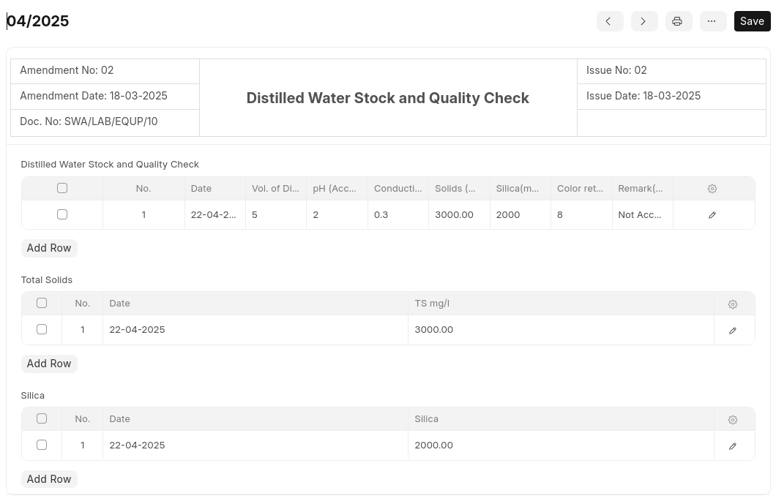

- Important Notes
Distilled Water Stock and Quality Check Alert generate after 7 days if last date within date no entry happen.
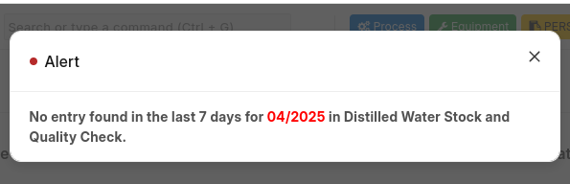

Figure – 4.7

Certified Reference Material List and Equipment Calibration Plan and Record (same Steps for both forms)
- In the above form Name wise entry happen when click to “New Certified Reference Material List” this button below type form open.
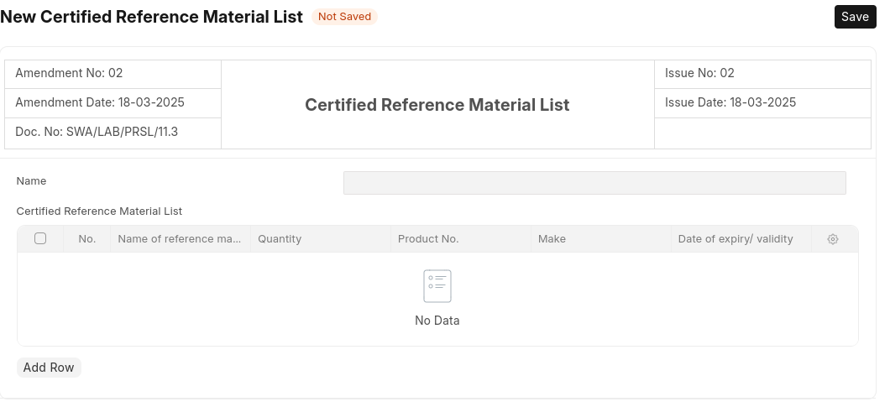
Figure – 4.8
- In name field add the name according to requirement , and after that table is display add the row here by click to “Add Row” button.
- An alert should be generated if the current date is 45 days before the 'Date of Expiry' specified in the table.
- In Equipment Calibration Plan and Record alert generate before one month.
- Make sure Name must be unique for each form in certified reference material list.
- For example , i have 2 form have 2 3 row add in both , like Microbiological and Heavy metals i add as a form name also have 2-3 entry , and the current date is before 45 days within specified table then alert generate like below figure.
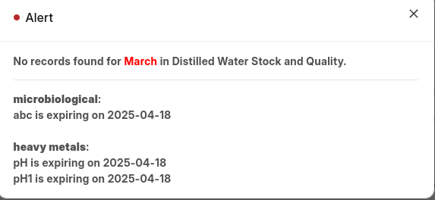
Figure – 4.9

- Instruments Record
- in the above form form is there having list of instruments and its details with expiry date , the date is after from today one month then notification occur. For example if the instrument expiry is on 22-05-2025 then one month before 22-04-2025 alert generate on the equipment dashoard.
- In Interument Records form create only one form and all the instrument add on this by click to “Add row” button.
- Equipment History Card
- This is only form Fill up as per value by click to new Equipement History Card button from the listview.

Personnel
This tab display from dashboard on top of right side.

- Employee Records
- This is only Form create individual form for each employee and fill up the detail as per your requirement.
By click to Add Employee records from listview form can be created.
- Form id is in series wise 01/04/2025 ,
where 01 – is incrreamental value , 04 – is current month , 2025 – current year.
- when the form is saved automatically List of Lab Personnel created by fetch value from employee records and set into the list of lab personnel values.
- Personnel Competence Assessment Record
- it is also from by click to “Add New Personnel Competence Assessment Record” form is create have same series like Employee records , list of lab personnel forms.

SOP , Procedure , General
- the above given is button display in dashboard we can upload file click to “Add File” button popup open from this popup upload file from your system and upload that file is saved in the particular list.
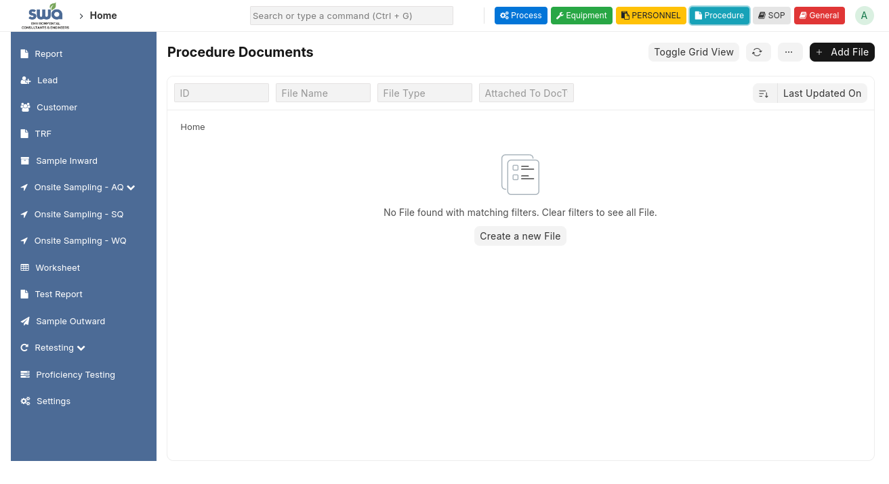
- All the file display in list after upload

